**Amplificatorul Diferential**

**Dragan Dan Stefan**

**Mardaloescu Serban**

**Nastase Liviu**

**Grupa: 325CA**

**Schema electrica**:

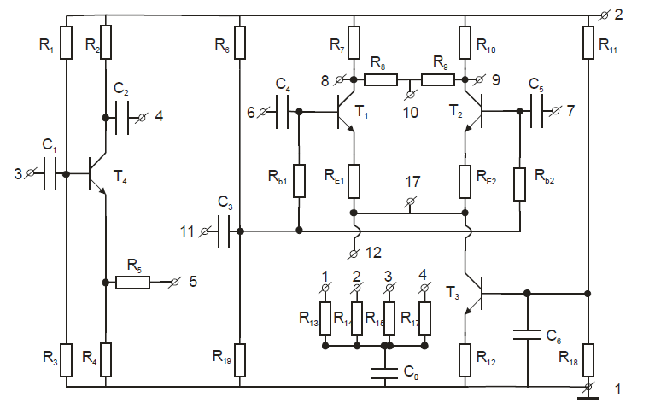

Valorile Rezistenţelor[Ω]:

|  |  |  |  |  |  |  |  |
| --- | --- | --- | --- | --- | --- | --- | --- |
| R1=15k | R4=1k | R7=2k7 | R10=2k7 | R13=47 | R16=47k | RE1=120k | Rb2=150k |
| R2=1k | R5=1k | R8=39k | R11=32k | R14=470 | R17=39k | RE2=120k |  |
| R3=6k2 | R6=47k | R9=30k | R12=470 | R15=4k7 | R18=15k | Rb1=150k |  |

1. **Determinare PSF pentru cele patru tranzistoare:**

|  |  |  |  |  |
| --- | --- | --- | --- | --- |
|  | **T1** | **T2** | **T3** | **T4** |
| **UC(V)** | 6.18 | 6.04 | 3.68 | 8.19 |
| **IC(mA)** | 1.65 | 1.84 | 3.53 | 4.00 |

1. **Excitatie simetrica, semnal sinusoidal**

Se leaga un generator de semnal intre bornele 3 si 1 si se aplica un semnal sinusoidal cu frecventa 1kHz si cu valoarea eficace de 20mV. Se masoara tensiunile de iesire adica U4 si U5 si se constata pe osciloscop ca acestea sunt in antifaza.

|  |  |
| --- | --- |
|  | **Date experimentale** |
| **U4(mV)** | 20.2 |
| **U5(mV)** | 19.8 |
|  |  |

1. **Masurarea amplificarii de tensiune Au si a Zi pentru T1 in montaj emitor la masa:**

V5 = 19,7mV

V8 = 278,2mV

Au = - V8 / V5 = -14,1

Zi || Rb = R5 * V5 / ( V3 – V5 )

V3 = 20 mV

Rb = 150 kΩ

=> Zi = 116 kΩ

1. **Excitatie simetrica diferentiala:**

|  |  |  |
| --- | --- | --- |
|  | **R0 🡪infinit** | **R0 = 47Ω** |
| **U1(mV)** | 368.8 | 370.4 |
| **U2(mV)** | 369.3 | 373.7 |
| **U0C(V)** | 1.1 | 1 |

U1 se masoara la borna 8

U2 se masoara la borna 9

U0C se masoara la borna 10

Se observa ca tensiunile U1 si U2 au aceeasi valoare si sunt in antifaza.

Se verifica relatiile pentru R0 🡪infinit, unde e = 20mV:

C:\Users\Radu\Desktop\Capture.JPG

Au = U1 / e = 18.44

Au = U2 / e = 18.46

1. **Excitatie nesimetrica diferentiala:**

|  |  |  |  |  |
| --- | --- | --- | --- | --- |
| **R0 (**Ω**)** | **U1(mV)** | **U2(mV)** | **U0c(mV)** | **r** |
| **47** | 191 | 8.5 | 181 | 1 |
| **470** | 289 | 74.5 | 106 | 1.3 |
| **4k7** | 213 | 163 | 42 | 4 |
| **47k** | 191 | 184 | 5.4 | 30.8 |
| **Infinit** | 188 | 191 | 0.77 | 299 |

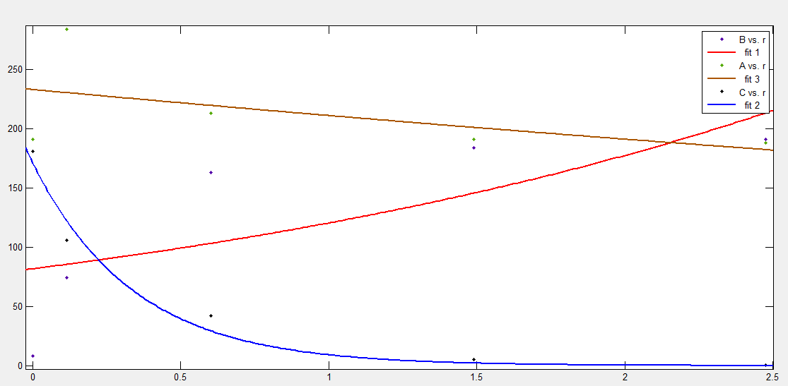

Legenda: A = U1, B = U2, C = Uoc

Impedanta de intrare pe modul diferential, pentru R0 -> infinit:

$Z_{int d1}= \frac{V_{5}}{V_{3}- V_{5}}R$

Zid1 = Zint d1 || Rb

V3 = 45 mV si V5 = 20 mV

Zint d1 = 1.8 kΩ

Zid1 = 1.08 kΩ

1. **Amplificator diferential pe mod comun:**

|  |  |  |  |  |  |
| --- | --- | --- | --- | --- | --- |
| **R0** | **47** | **470** | **4k7** | **47k** | **infinit** |
| **U1(mV)** | 1910 | 1110 | 280 | 36 | 12 |
| **U2(mV)** | 1870 | 1080 | 278 | 36 | 12 |
| **U0C(mV)** | 1990 | 1100 | 277 | 39 | 14 |
| **r** | 1.59 | 6.96 | 59.63 | 597 | ∞ |
| **r(teoretic)** | 1.11 | 2.02 | 8.03 | 57.1 | 0 |

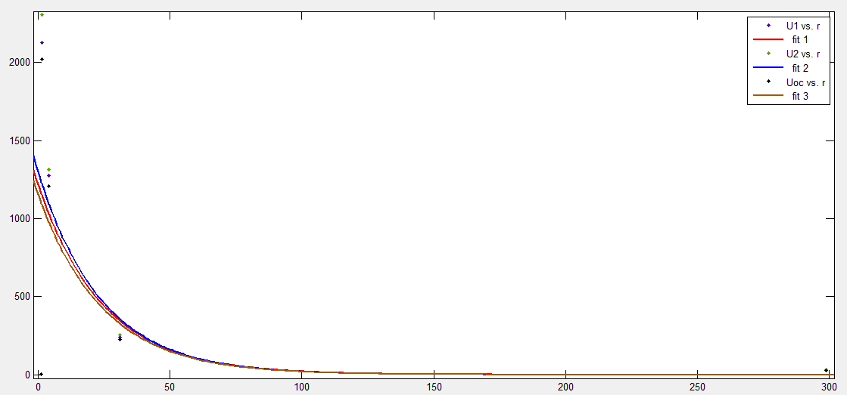

Se observa ca graficele celor trei tensiuni se vor suprapune aproximativ.In urma calculelor, valorile masurate si cele teoretice nu vor coincide din cauza defectelor de aparatura sau a erorilor umane ce apar in calcule si masuratori.

1. Se calculeaza coeficientul de rejectie rs pentru Ec = 17 V ( = 1)

|  |  |  |  |
| --- | --- | --- | --- |
| Ec (V) | V8 (V) | V9(V) | () |
| 18.2 | 11.42 | 11.60 | 5.5 |
| 17.2 | 10.93 | 11.09 | 6.25 |